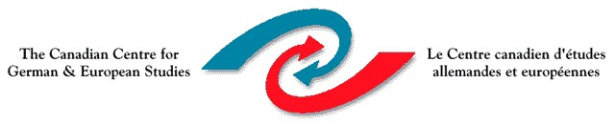
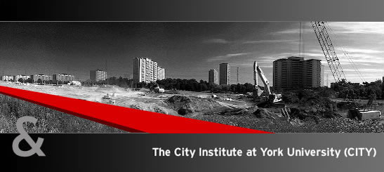

Dietmar Schirmer
University of Florida

High-Modernism and Mass Utopia
in Twentieth-Century Urban Planning

Friday November 9, 2012
12:30-2:30 pm
Room 280A, York lanes, York University

Together with the CITY Institute at York, CCGES will host a talk by Dietmar Schirmer (DAAD visiting professor at the University of Florida Department of Political Science) Friday, November 9th from 12:30 to 2:30 pm in room 280A York Lanes.

Dietmar Schirmer, Ph.D. in Political Science from Free University Berlin, 1990, is a DAAD visiting professor at the University of Florida Department of Political Science. He has taught at Free University Berlin, University of Vienna (2004), at Cornell (1998-2003), and the University of British Columbia. Dietmar Schirmer was a Fellow at the German Historical Institute in Washington, D.C., from 1992-1995.
Research Interests: Comparative Politics and Historical Sociology, regional specialization in Europe. Current research agenda in state-formation, nationalism, and European integration and in the aesthetics of the state
Recent Publications: The Beautiful State: Architecture and Political Authority in Europe Since the Renaissance (under review at Cornell University Press); “State, Volk, and Monumental Architecture in Nazi-Era Berlin," in: Andreas Daum and Christoph Mauch, eds., Berlin – Washington, 1800 – 2000: Capital Cities, Cultural Representation, and National Identities, Cambridge, UK, and New York: Cambridge University Press, 2005, 127-153; “Closing the Nation: Nationalism and Statism in 19th and 20th Century Germany,” in: Sima Godfrey and Frank Unger, eds., The Shifting Foundations of Modern Nation States, Toronto: University of Toronto Press, 2004, 35-58; Identity and Intolerance: Nationalism, Racism, and Xenophobia in Germany and the United States, Cambridge, UK, and New York: Cambridge University Press 1998 and 2002 (ed. with Norbert Finzsch).

All are welcome, but attendees are asked to register with ccges@yorku.ca

