


Intellectuals and Society
Lecture Series

Sex and the Citizen: Reflections on Citizens, Satyrs
and Sexuality in the Athenian Democracy”
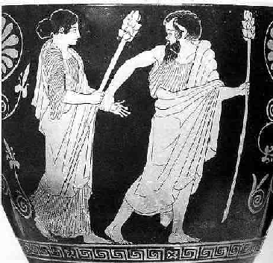

Allison Surtees

Wednesday, April 1, 2009
3:00-5:00 p.m.
Junior Common Room, 024E Founders College
Open to All
Light refreshments will be served

Athenian citizens defined their place in society in binary terms, a fact
reflected in continual contrast between themselves and others, be they women, slaves, or resident aliens. Readings of the satyr (half-man, half-horse) as “other” often explore this mythical figure as a cautionary tale for the citizen with respect to moral and sexual behaviour. This paper examines how the figure of the satyr changes with the changing ideas of democracy and citizenship, and how this mythical creature both contrasts and reflect citizen sexual behaviour.

Allison Surtees is a PhD candidate in Classics at Johns Hopkins University in Baltimore. During the course of her graduate studies she has held doctoral and research fellowships at Mount Allison University, the Walters Art Museum in Baltimore, the Canadian Institute in Greece and the American School of Classical Studies in Athens. She has also been a visiting student in the Archäologisches Institut in Freiburg, and has taught at Memorial University of Newfoundland, Mount Allison University and York University. Her dissertation examines various methodologies for the study of Greek statuary focusing on one satyr statue-type. More broadly her research is interested satyr iconography in general, from Archaic Athens to Imperial Rome.

Office of the Master:
(416) 736-5148
franca@yorku.ca

Founders College

