September 10 speaking notes

Places for questions (responses in class)
Discussion session minutes
Moodle discussion forum
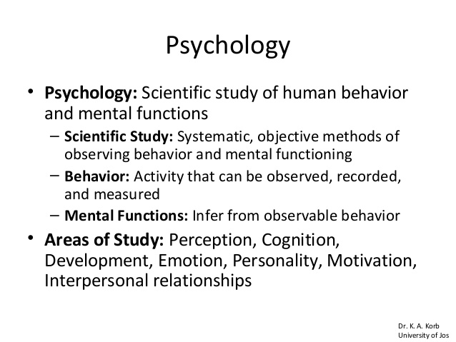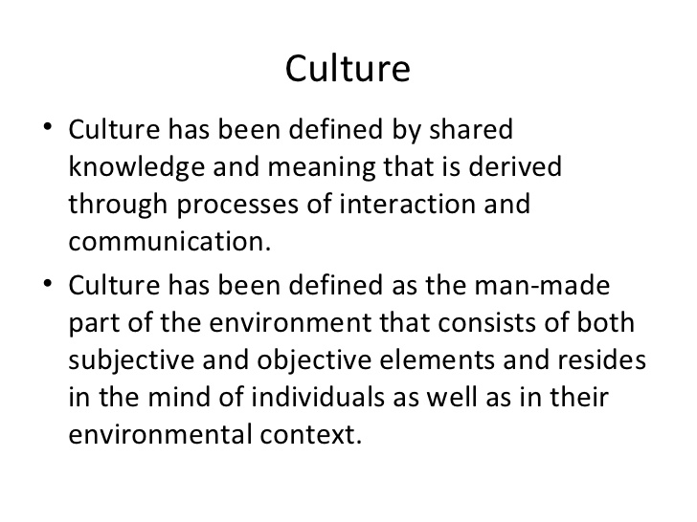

Material culture, immaterial culture

Norms; Durkheim – collective representation; Mead – significant symbols, shared meaning of things, symbolic interactionism; Moghaddam – carriers, Moscovici – social representations

Culture – capacity for constantly expanding the range and accuracy of one’s perception of meanings (Dewey: Democracy and Education）

- the way of life of a group of people
- the structure of their social life

Nature and nurture, experimentation

Culture terms:
Cultural deprivation
Culturally relevant pedagogy
Celebrity culture
Cultural capital
Culture wars
Cultural identity
Culture of poverty
Media culture
High culture, low culture
Cultural revolution
Cultural relativism
Cultural transmission
Culture clash
Peer culture
Culture-free testing
Multiculturalism
Middle-class culture
Police culture, military culture, prison culture

General divisions of our reading this term:
Orientation – what is cultural psychology?
Phenomena – what are the phenomena that differ across cultures?
- what are some examples of cultures other than national cultures?
Mechanisms – how does culture have its effect on psychological phenomena?
Multiculturalism – what happens when cultures mix?
Indigenous Psychologies – Is Psychology a product of a particular culture?
- how do other cultures think about phenomena that Psychologicsts call psychological?
Globalization – What are the effects of the spread of Western Psychology to other cultures?
The culture of education – Is academic culture a thing? Does it welcome immigration?

Heine and Ruby article:
Tips on reading academic articles
Note the main headings
Humans as a cultural species (universals)
Enculturation (socialization)
The self (conceptions and their effects)
Motivation
Culture and emotion
Cognition and perception
Conclusion (methodology comments)
(throughout note references to meaning, meaning systems, beliefs, values)

Sinha article:
History: how cross-cultural Ψ moved towards cultural and indigenous Ψ
Some names you may have seen before: Wundt, Galton, Darwin, Freud, Bartlett (memory processes)
WASPs
An acultural (a cultural) psychology
Does it matter that Ψ mostly studies sophomores?
Envelope, package, peel the onion, remove the noisy, confounding variables
Parenting practices, life-styles, schooling, …
Cross-cultural Ψ began as a methodological WASP strategy in search of universals
Culture as outside, rather than part of a culture/behaviour system (ABCs) – determinants, variables
Cross-cultural psychology
Etic, emic, derived etic approaches

Where does culture enter the psychological arena?
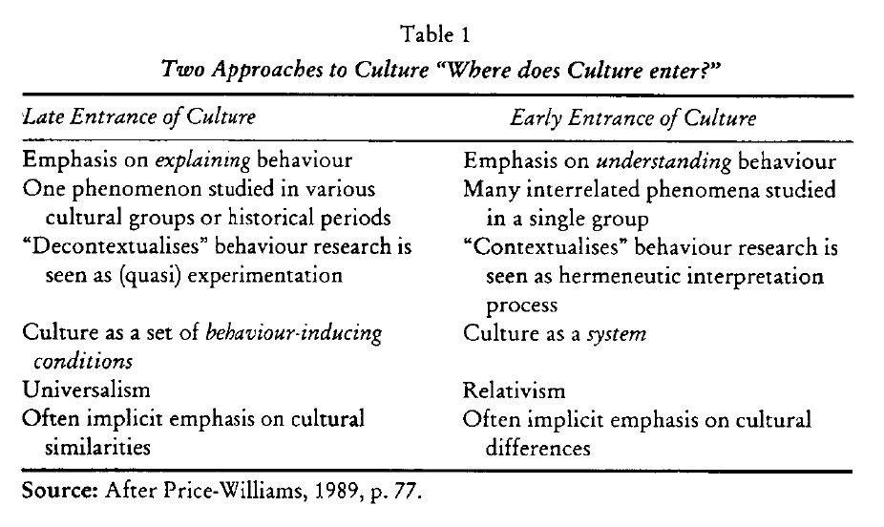

Greenfield article:
Psychology of culture
3 approaches: cross-cultural Ψ, cultural Ψ, indigenous Ψ
Treating culture as a variable, external, envelope (internal processes)
Psychology as a product of western culture – an indigenous Ψ
Universal laws, rather than patterns relative to time and place
Nomothetic, rather than idiographic
Cause and effect, rather than other forms of relationships/patterns
Interpretations of situations in terms of meanings (hermeneutic)
Objective truth rather than subjective perspective
Isolation of variables in labs, rather than natural observation
Greenfield emphasizes two processes:
The construction of shared meaning – cultural Ψ’s prime concern
Development/socialization
Previously western psychologists thought they were studying the self
Notion of self is cultural
Western psychology as an indigenous psychology
Independence, individual -- interdependent, relational, collective
How to deal with the personal vs. group tension?
Postulate on p. 230
All cultures must handle the issue of the relationship between person and group; and there are two basic alternatives: prioritize the individual or prioritize the group (particularly in-groups such as family).
Individualist society studies individual variation – intelligence
Collectivist society more likely to study group variation – in-groups
Names you will see again: Hofstede, Kagitcibasi, Markus
Hofstede comparison of national cultures – China and US (as IVs)

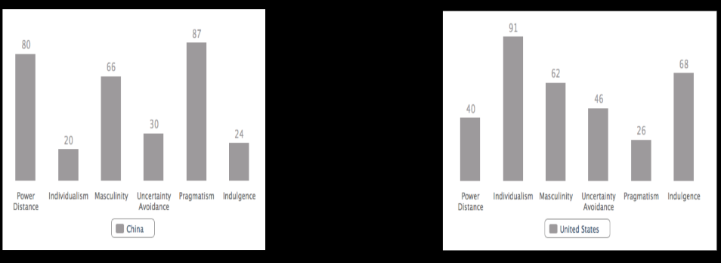

Universal theory of cultural differentiation
Culture is structured like language
Methodology: unobtrusive observation (video), ethnography, discourse analysis

