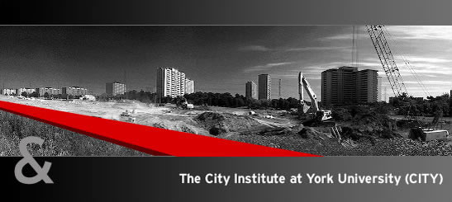

The City Seminar

An interdisciplinary series of presentations and discussions on urban landscapes, past and present.

Jack Layton
MP and Leader of Canada’s NDP
“Canada’s Urban Future”

Friday October 19th, 2007
1:00 - 2:30 pm

Senate Chamber

940 Ross Building North

Everyone is welcome.

