Before you begin, please ensure you have:
- Your 9 digit employee ID number
- Last four digits of your Social Insurance Number

Setting up a Passport York & Central Email Account

- Go to Manage My Services by entering in the address bar of your web browser: http://mms.yorku.ca
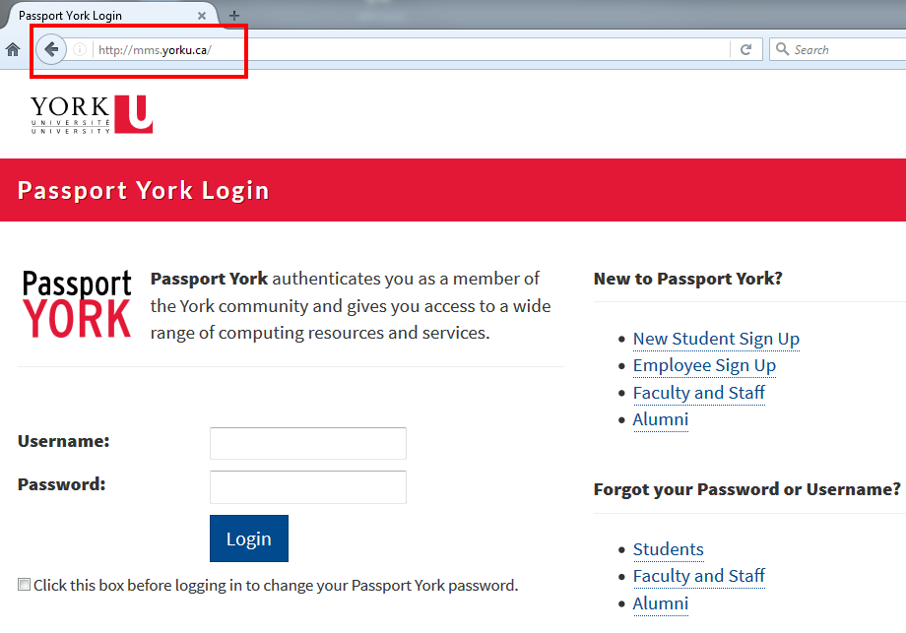

- Click on Employee Sign Up
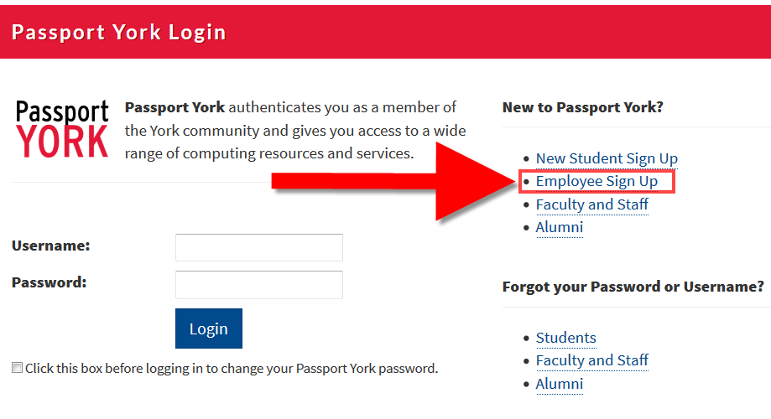

- Enter your Username and Password, click Sign Up.
Username: your 9 digit employee ID number (see ‘a’ below if you do not have your employee ID number)
Password: last 4 digits of Social Insurance number and last 4 letters in surname (please note on screen Surname rules).
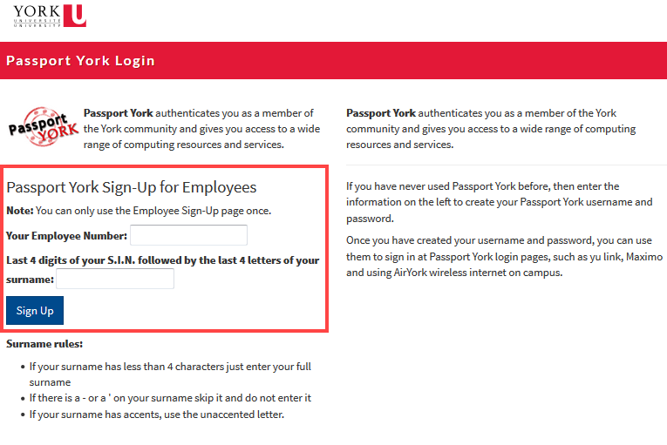

  - If you do not have your employee ID number, this can be found at the top of a pay stub. Please see example below. Your Manager can also provide you with this information.

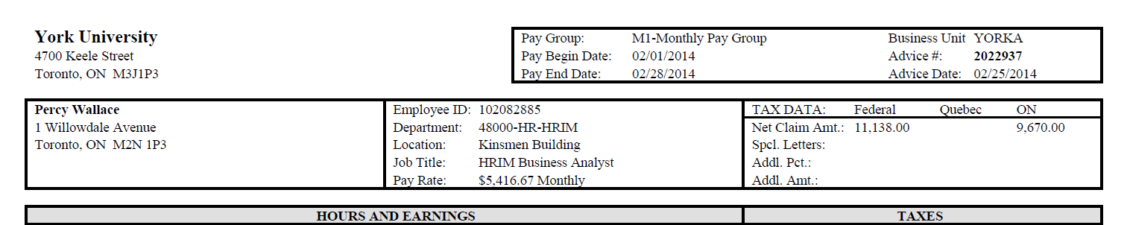

- You will now be asked to enter a username. This name will be used for both your staff email address, and your Passport York account.
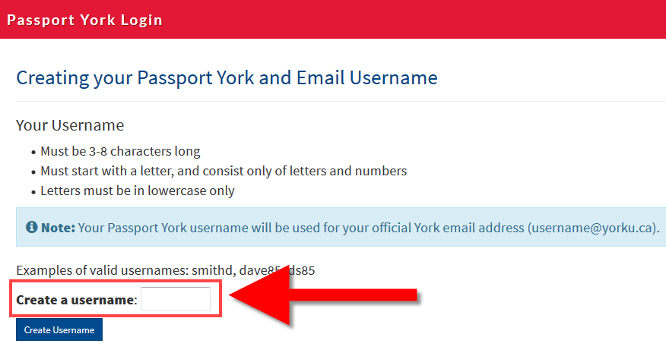

- Click ‘Create Username’
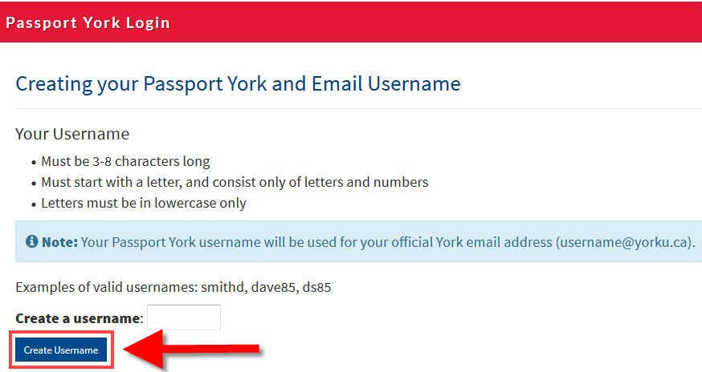

- If the username you choose is being used by someone else, you will receive the following message. Simply replace the username you had selected with a new one, and click ‘Create Username’ again.
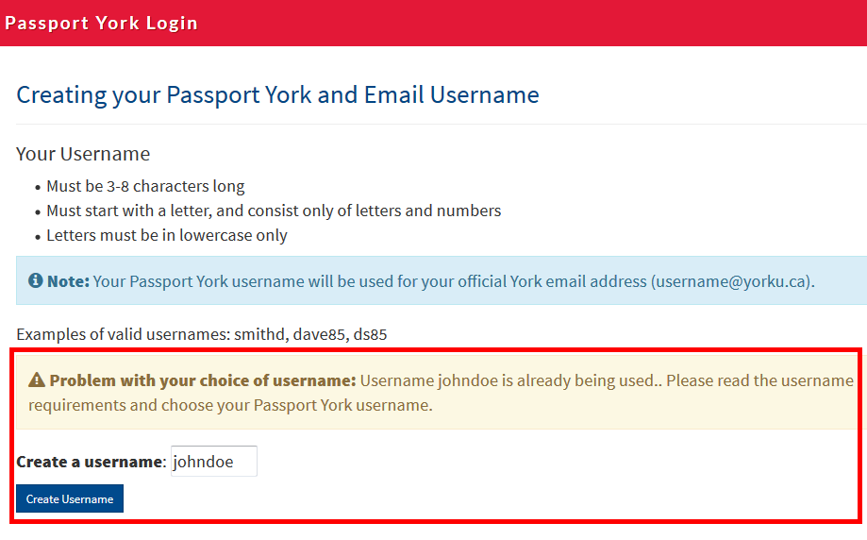

- When your username choice is accepted, you will receive an attention screen. Write down your username.
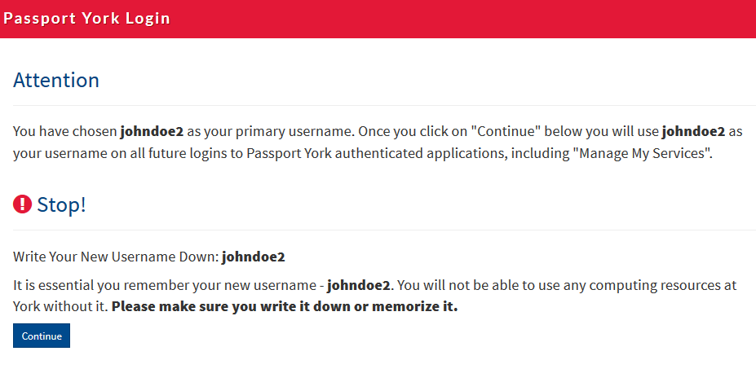

- Click continue.
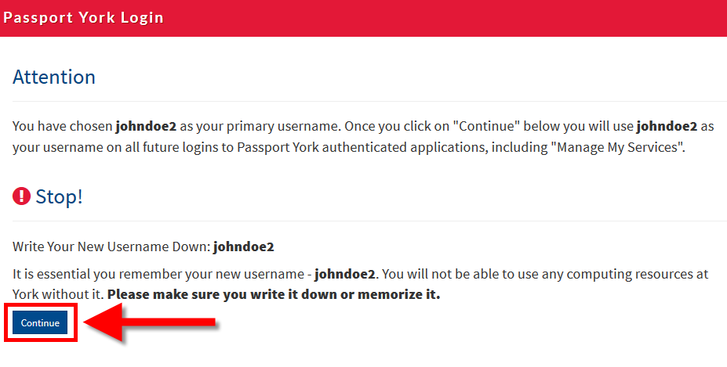

- You will now be prompted to change your password. Enter your current passport York password (last 4 digits of SIN, last 4 letters in last name). Use the Password Guidelines to select a new password, and enter.
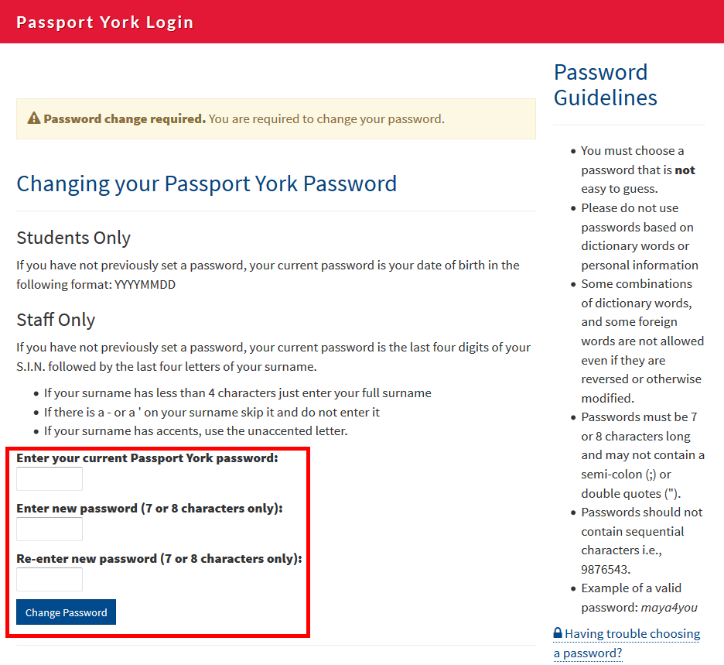

- Click change password.
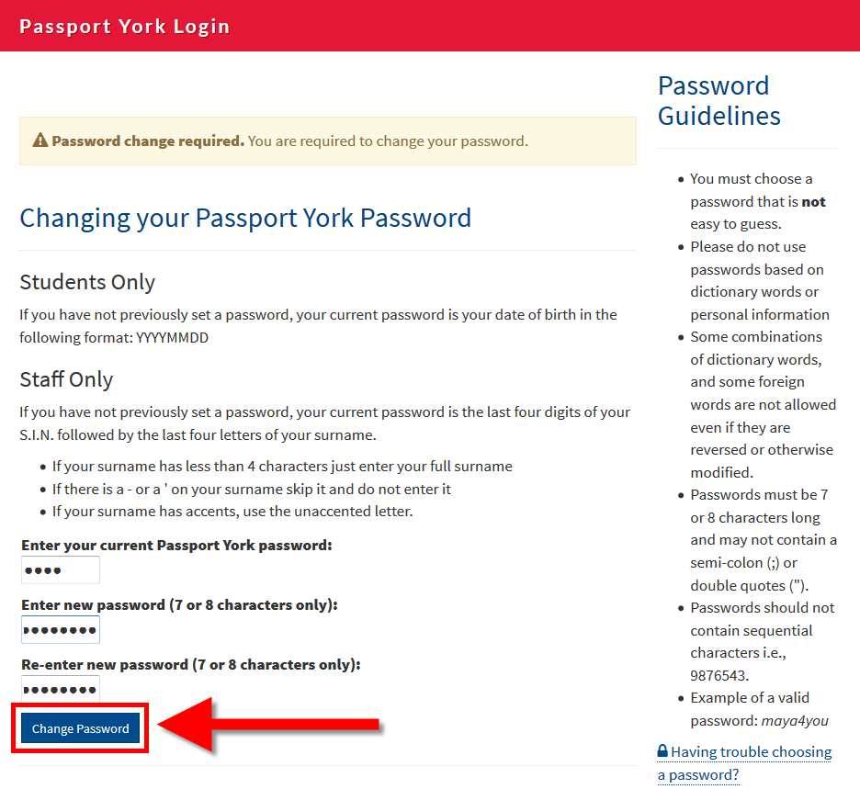

Success! You’ve changed your password. Your Passport York account consists of the:
1 – Username: the username you just created
2 – The password that has just been successfully created.

- Please click Continue.
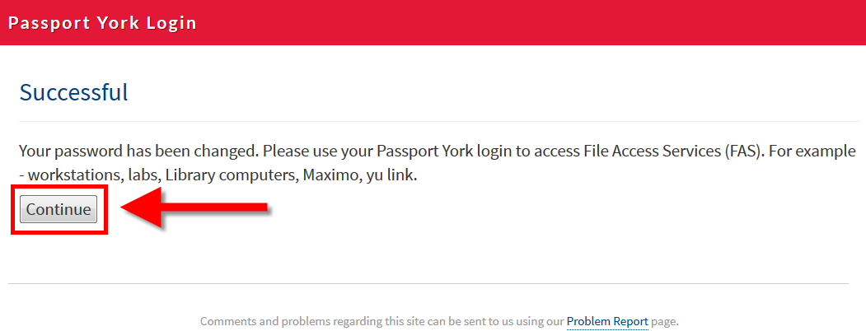

- You will now be prompted to set up security questions, in the event that you lose your Passport York password. Click OK.
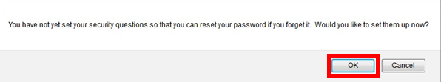

- Select security questions from each drop down menu, and type your answer in the space provided below each. All questions must be completed. Once finished, click Set Questions.
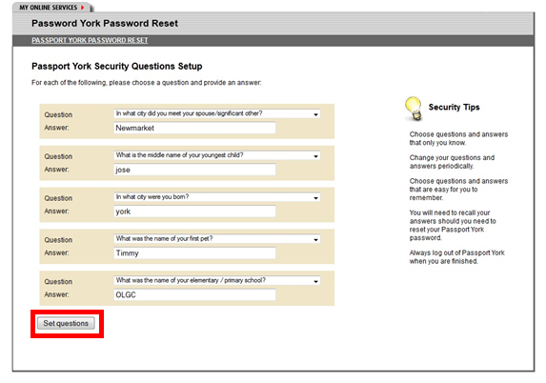

- You will be presented with a confirmation screen that confirms your security questions have been set. You have completed set up of your Passport York account and central email account. Click Logout.
